**Practical No - 03 (Group A)**

Name: Atharva Bipin Iparkar Date : 03/09/2024

Roll No: S211045

Div: A

Batch: A2

Problem Statement :

Imagine a publishing company which does marketing of book & cassette. Create class publication that stores title (String) & price (float) of a publication from this class derive 2 classes; book, which adds a page count type (int) & tape which adds a playing (float) time in minutes. Write program that instantaneous book & tape classes, allows user to enter data & displays data members if an execption is caught replace all data members with a value.

Program Code :

#include<iostream>

using namespace std;

class publication {

public :

string title;

float price;

};

class book : public publication {

public :

int pagecount;

void getdata();

void display();

};

class tape : public publication {

public :

float time;

void getdata();

void display();

};

void book :: getdata() {

cout<<"Enter the title of book : ";

cin>>title;

cout<<"Enter the price of book: ";

cin>>price;

cout<<"Enter no. of pages : ";

cin>>pagecount;

cout<<"\n";

}

void tape :: getdata() {

cout<<"Enter the title of cassete : ";

cin>>title;

cout<<"Enter the price of casette : ";

cin>>price;

cout<<"Enter time in minutes : ";

cin>>time;

cout<<"\n";

}

void book :: display() {

if(pagecount <= 0 || title == " " || price == 0) {

title = " ";

price = 0;

pagecount = 0;

cout<<"The title of book is : "<<title<<endl;

cout<<"The price of book is : "<<price<<endl;

cout<<"No. of pages : "<<pagecount<<endl<<endl;

} else {

cout<<"The title of book is : "<<title<<endl;

cout<<"The price of book is : "<<price<<endl;

cout<<"No. of pages : "<<pagecount<<endl<<endl;

}

}

void tape :: display() {

if(time <= 0 || title == " " || price == 0) {

title = " ";

price = 0;

time = 0;

cout<<"The title of cassete is : "<<title<<endl;

cout<<"The price of cassete is : "<<price<<endl;

cout<<"Time in minutes : "<<time<<" min"<<endl<<endl;

} else {

cout<<"The title of cassete is : "<<title<<endl;

cout<<"The price of cassete is : "<<price<<endl;

cout<<"Time in minutes : "<<time<<" min"<<endl;

}

}

int main() {

book b;

tape t;

b.getdata();

t.getdata();

b.display();

t.display();

return 0;

}

Output :

Without execption :

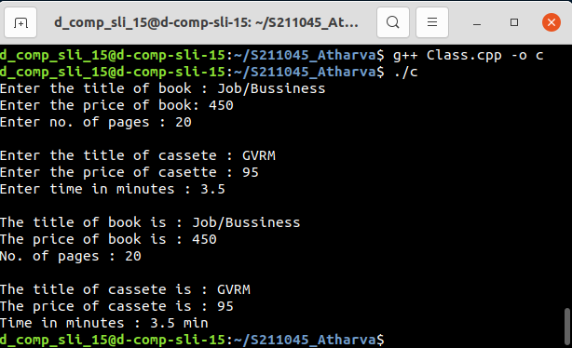

With execption :